M.SAILAJA

192011471

1. Dynamic Routing using Packet Tracer ( Distance Vector Routing)

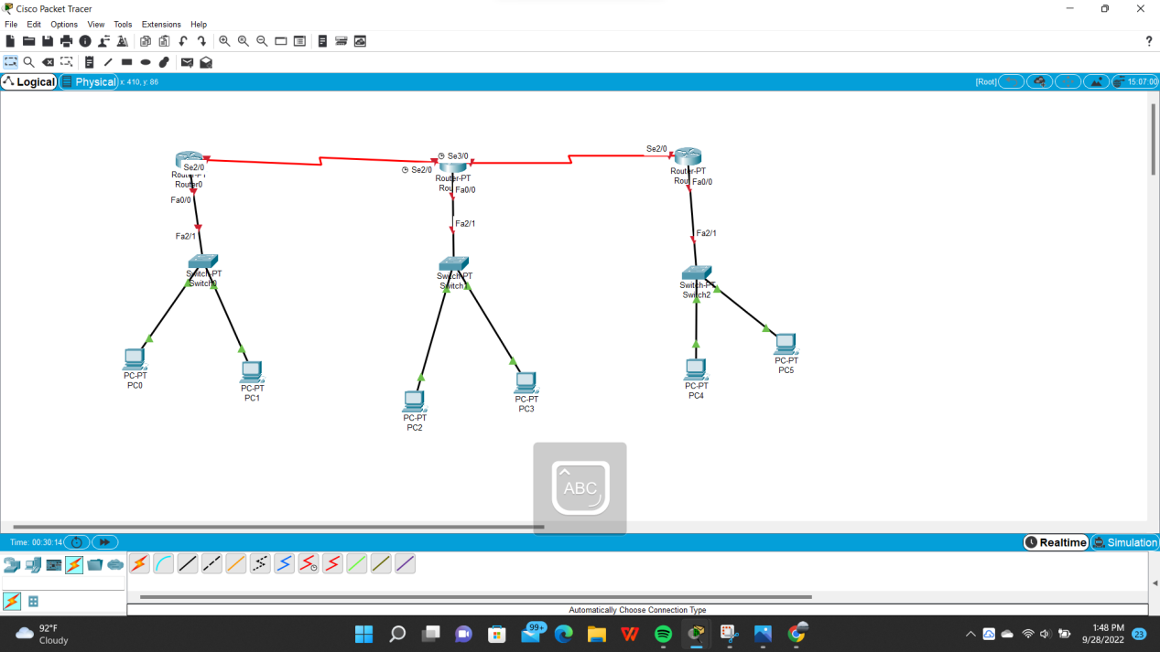

\* 6 pc’S,3 Switches,3 Routers are used

\* Connections are given as shown above

\*ip address is set

\*Simulation is done

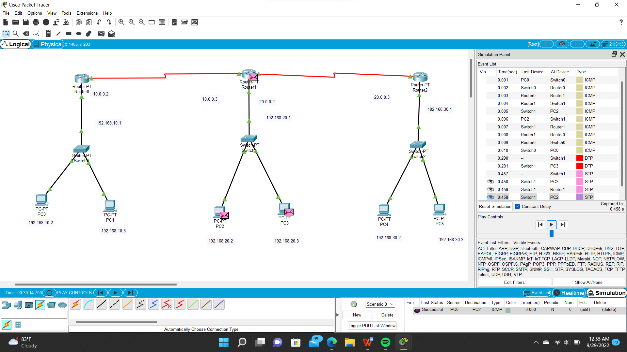

We can able to see packet is tranferring



\*we get output as successful

